Responsive Design And Bootstrap Grid System Part – 1

The jumbotron component allows you to set

apart the content inside the jumbotron from the rest of the page.

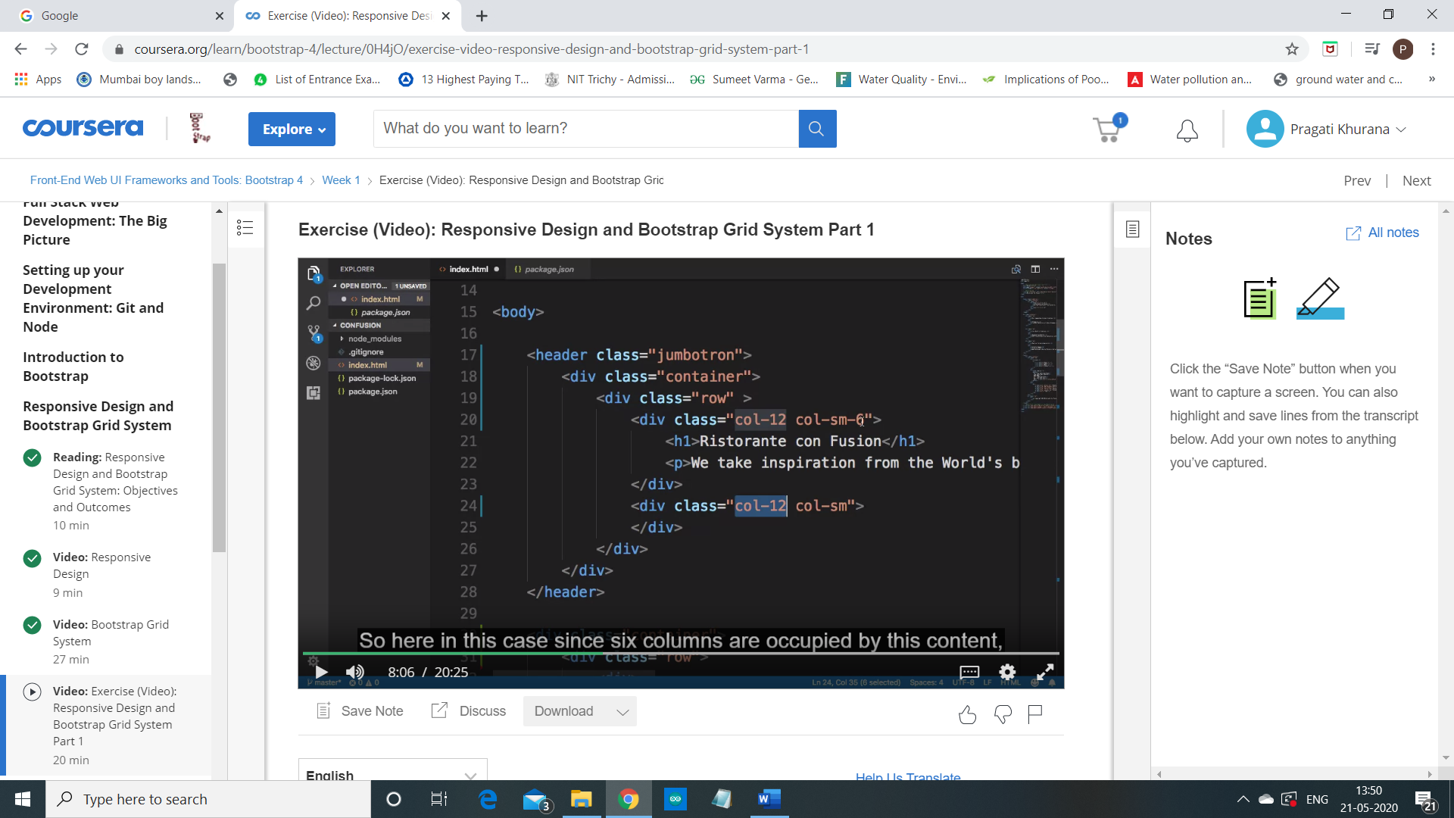

So going to the header, to the second inner div inside the jumbotron here,

let me apply a class as column 12, column sm-6.

So, here the content in

this first div will occupy the entire row for extra small screen sizes,

and then will occupy half the row so that's why column

sm-6 for small to extra large screen sizes.

Now, similarly for the second div here,

although it doesn't contain any content there,

I'm going to define the column classes here as column 12 and then column sm.

So, notice that here by specifying column 12,

I'm explicitly stating that for extra small screen sizes whatever content is

inside this div will be stacked below the content about here.

And then for small to extra large screen sizes,

this content will occupy the leftover amount of

columns in the row for small to extra large screen sizes.